Project info
The MEA Opportunities Commercial Optimisation Hopper and Report is a Power BI dashboard based on an excel hopper used to monitor Commercial Opportunities for the Middle East & Africa Region. It uses the data found in the MEA Profit Opportunities Tracker 21.04 which can be found on the MEA Commercial Optimisation Team Channel.
The MEA Profit Opportunities Tracker is an excel file that lists the Asks, Levers and the estimates in 3 different estimation levels Hopper, ICT Estimates, and Contract. The different estimation levels are used to show how accurate were we by comparing the estimation levels in the Baseline tab in the Power BI Dashboard.

MEA Profit Opportunities Tracker 21.04
The Opportunities Hopper, is the excel sheet where the data used for the Dashboard is used. It is split into the following sheets

MEA LOG
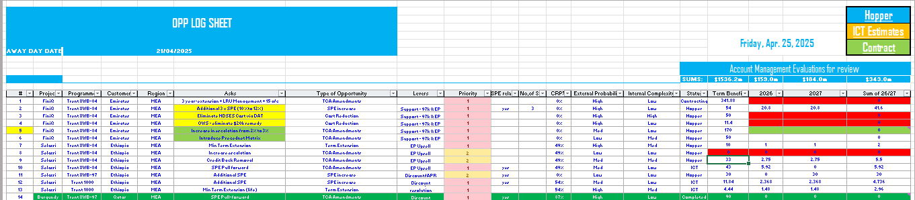
The “MEA LOG” sheet lists the opportunities and any related details. This is where new opportunities is to be added, along with any details relating to the opportunity i.e. Project name, Customer, Levers, Priority, Probability and Complexity. The Status (found in column Q) is to be updated as opportunities mature through the Status levels mentioned below:
- Hopper: Opportunity is defined and listed in the hopper
- ICT: Approval to chase the Opportunity is obtained and an ICT is currently chasing the opportunity
- Negotiations: Rolls-Royce is currently in contact with the specified customer on the opportunity
- Contracting: Proposal and/or any relevant documents is signed by the customer, and a contract is being developed/amended
- Completed: Contract is signed and profit is actualised.
The “Hopper” level is where initial Account Management Evaluations Estimate is to be Inputted, however, as BE gets developed and more accurate estimates are evaluated, it is recommended to input new Term Benefit, 2026, and 2027 estimates in the ICT Estimates that can be accessed by clicking the ICT Estimates (which can be shown in the top right of Figure.1).
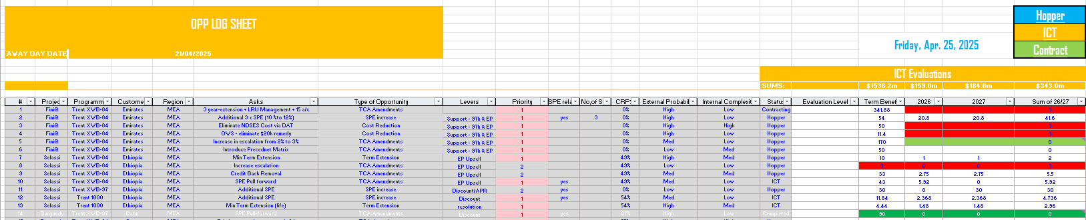
The ICT Estimates (shown as L2 sheet in the excel workbook) is to only include Profit Impact estimates that was evaluated by the ICT team, Service Business, or BE teams. Columns C through Q is shaded as no input (other than estimates) should be inputted in the ICT sheet.
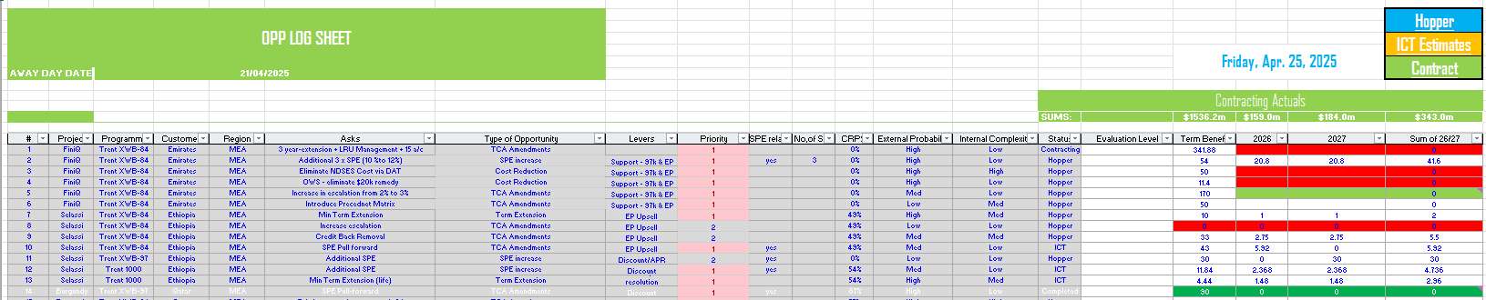
Similar to the ICT Estimates, Contract Levels will include the estimates evaluated at the contracting level.

Timeline Sheet
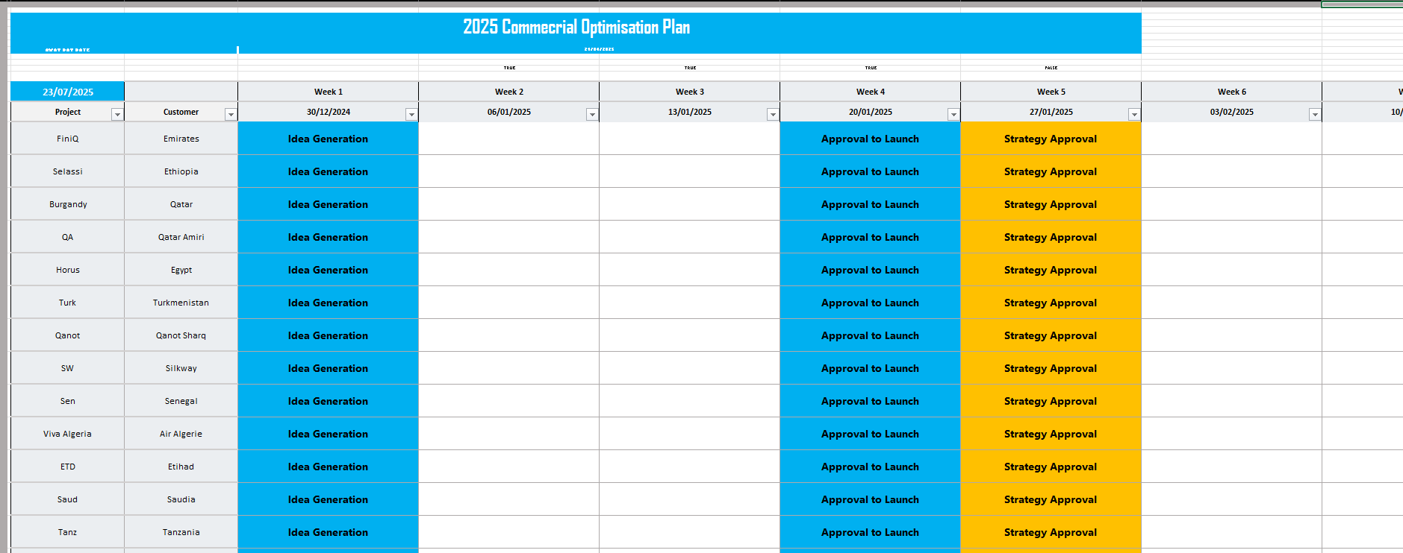
The Timeline sheet shows the Timeline and milestones set against each project. The Major milestones set for all projects are as follows:
- Hopper
  - Idea Generation
  - Approval to Launch
- ICT
  - Strategy Approval
  - BE Generated
  - Approval
- Negotiations
  - Negotiation Strategy
  - Proposal Submitted
  - Proposal Signed
Timelines will be inputted through “Date Input Sheet”. Please make sure the dates entered in the “Date Input” sheet is consistent and NO milestones are set on the same week.

MEA Commercial Optimisation Dashboard (Power BI Report)

Data Connection
The Power BI runs of the data found in the Hopper file. The data is connected via a SharePoint folder connection to the MEA Commercial Optimisation SharePoint.
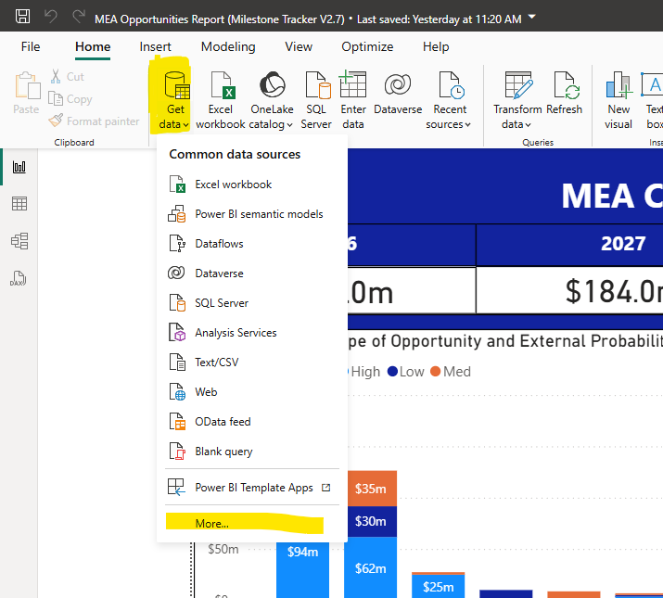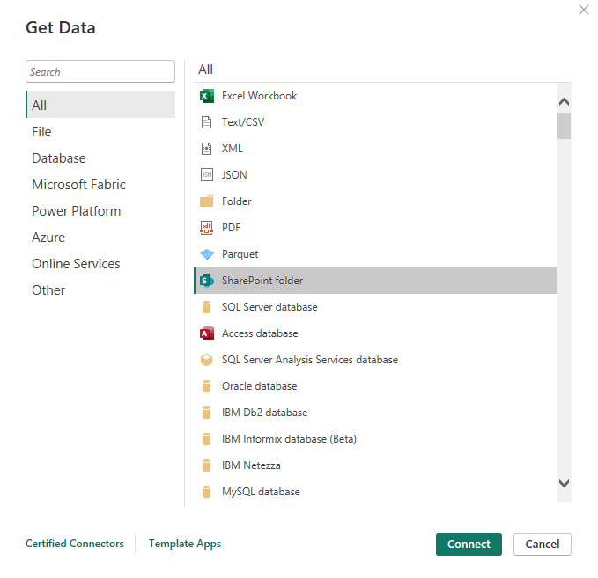
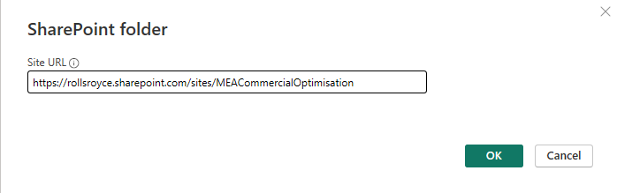
This generates a query of all files that can be found in the SharePoint folder, from which the “MEA Profit Opportunity Tracker 21.04.xlsx” was selected, and the “MEA LOG” sheet was imported to create the “LOG sheet” Query.
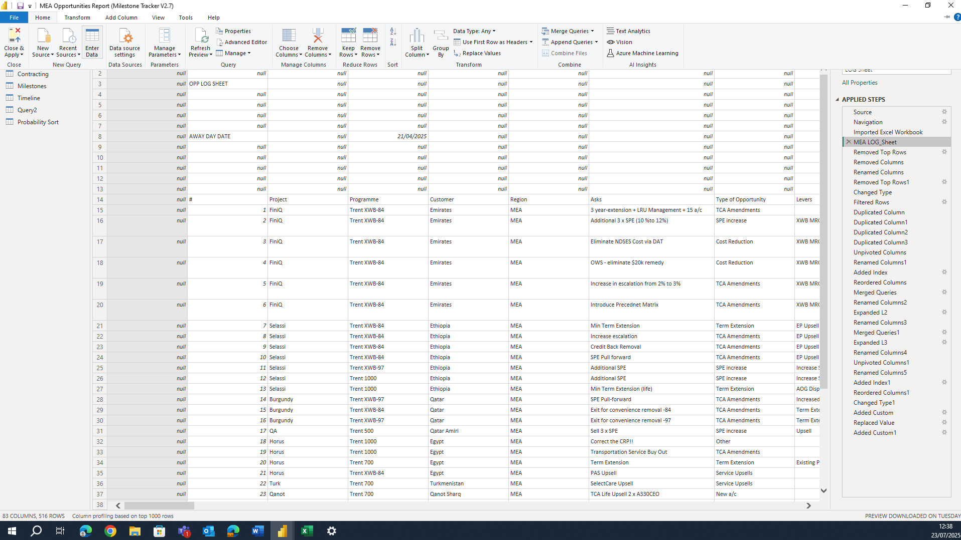
Clean up of the query can be done by removing the Top empty rows, unnecessary columns. Troubleshooting can be done through this tab as it shows where the error is located depending on the applied Power Query Step.
The following Queries are used in the Power BI Report:
LOG Sheet | Data extracted from the “MEA LOG” sheet
ICT | Data Extracted from the “ICT Estimates”/L2 Sheet
Contracting | Data Extracted from the “Contracting”/L3 sheet
Timeline | Timeline data that can be found in “Timeline” sheet
The extracted queries are linked to the following Datasets

Calendar_Weekly | Used to generate the Timeline Matrix found in the Timeline tab
Customer_W/C | Used to link the milestones and customer to the Calendar_Weekly
Dataset
Probability Sort | Used to sort the probability from Low to High in Power BI visuals
Project Status | Lists all Customers and Projects
Status_Stages | Sort the Milestones used in the Timeline
Week Commence Dates | Used to generate a list of all Week Commence dates from 30-12-2024 to 20-12-2027

Report tab
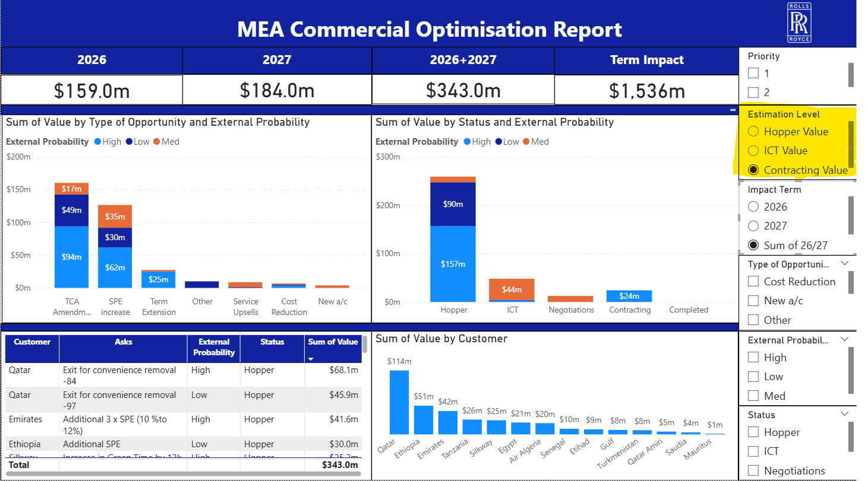
The report tab visualises financial impact of all opportunities. The Totals that can be found on the top of the report shows the sum per the corresponding term. They’re effected by any filters that are applied on the report, showing the totals for a specific customer, opportunity type, or sum of impact all opportunities in a specific status.
The Estimation level can be selected using the “Estimation Level” filter found on the rightmost section of the tab.

Baseline tab

The Baseline tab is where includes a line graph that can be shown in the bottom section showing the difference between the Hopper, ICT and Contracting Estimates, Totals can be shown on the left of the estimation baseline

Timeline Tab
The Timeline tab shows the projects planned timelines based on the timeline sheet. The time line matrix which can be shown on the bottom section, monitors the current progression phase through Hopper, ICT and Negotiations. The tracker sets the Proposal signature as the Project Completion date, and the days left until the planned proposal signature can be shown for each project.

